Manuscript template for the final preparation of the accepted paper
(Times New Roman, Font 14)
Arunesh Chandra¹, Pratibha Kumari¹, Subodh Kr. Sharma¹ and Anurag Gupta^{2*} (Times New Roman, Font 11.5)
¹Department of Mechanical Engineering, KIET Group of Institutions, Ghaziabad, India
^{2,*}Department of Mechanical Engineering, KIET Group of Institutions, Delhi, India (Times New Roman, Font 8, Italic, * Corresponding Author)

----------------------------------------------------------------------------------------------------------------------------------------------------------------------------------------------------------------------------------------------------------------------------------------------
Abstract

Abstract must be written in Times New Roman, font 9. In present study, as a basic step for modeling the fatigue behavior of an extruded Al alloy cylinder, the fatigue crack growth data of the alloy was collected in two orientations. Microstructural analysis revealed that the material had recrystallized grains and clusters of constituent particles aligned in the direction of extrusion. Fatigue life of the samples revealed a shorter fatigue life representing a higher fatigue crack growth rate in transverse direction.

Keywords: At least four keywords; In alphabetical order; Separated by semicolon; Design of experiments (Times New Roman, font 8, upper case at the beginning of each keyword)
----------------------------------------------------------------------------------------------------------------------------------------------------------------------------------------------------------------------------------------------------------------------------------------------

1. Introduction
This document is a template for Microsoft Word. If you are reading a paper version of this document, please download an electronic file from the conference website, http://moodleit.kiet.edu/ICRTIME2k18/home.html, so you can use it to prepare your manuscript. Please do not use other templates.
The author(s) is requested to prepare the final two-column camera-ready version, the author(s) must follow these instructions strictly in order to maintain the high standard of the journal.
The paper is divided into three parts. The first part includes the title, author’s name, abstract, and keywords. The second part is the main body of the paper that includes the references and nomenclature. The third part is the author’s profile.
The main text must be written in Times New Roman, font 9.5, and line spacing of 12 points. The font size, line spacing, and margin of the template must not be altered.
References should be listed at the end of the paper and arranged in order. References should be cited in the main text by numerals in a square bracket [1-3].

2. Section (Times New Roman, Font 10, Bold)
2.1 Subsection (Times New Roman, 9.5, Italic, Bold)
The second part consisting of the paper body must be edited in double column format. Figures and tables should be located at top or bottom of either column.
Clear original figures in black and white should be used. Equations should be numbered consecutively throughout the paper and located at the right margin as in Eq. (1) below. Figures and tables should be placed at the top or at the bottom of each column as in Fig. 1 and Table 1.

Table 1. Material properties of SCP10.

Young’s modulus (GPa) | 210
Poisson’s ratio | 0.3
Yield Strength (MPa) | 433
UTS (MPa) | 460

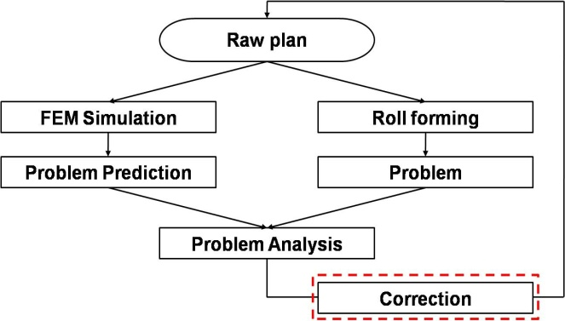

Fig. 1. Flow chart for the correction of the roll forming process design.

For instance, Eq. (1) is used to calculate a response surface as follows:

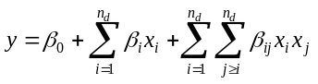 (1)
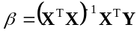 (2)

where x_{i} denotes the design variables, n_{d} is the number of design variables, β_{i} is the unknown coefficient, and denotes the design matrix comprising experimental points. The settings of the font size to prepare the equations are:
Main equation: 9.5 pt (Times New Roman),
Subscript/superscript: 6 pt (Times New Roman),
Sub-subscript: 5 pt (Times New Roman),
Symbol: 18 point,
Sub-symbol: 12 point.

2.2 Reference
References (in font 9) should appear in a separate bibliography at the end of the paper, with items referred to by numerals in square brackets. All journal articles must include volume, number, and pages. The journal title, conference title, and book title must be in italic.

3. Conclusions
Clarity of all figures is extremely important. If the final version is not prepared in two column format or does not include author(s)’ biographies, the publication process will be delayed. The manuscript received, revised and accepted dates will be checked and corrected by the review committee.

Acknowledgment
This work supported by Research Program supported by the Department of Education and Technology (program name), Country Name.

Nomenclature (if any)
E : (Effective) work potential
E₀ : Exergy
E₀₀ : Energy of a system
K : Kelvin temperature scale
S : Entropy
T : Temperature or Celsius temperature scale
W : Effective work

References
- C. S. Kim, K. S. Hong, and M. K. Kim, Nonlinear robust control of a hydraulic elevator, Control Engineering Practice, 13 (6) (2005) 789-803.
- R. S. Chandel and S. R. Bala, Effect of welding parameters and groove angle on the soundness of root beads deposited by the SAW process, Proc. of Trends in Welding Research, Gatlinburg, Tennessee, USA (1986) 479-385.
- S. Kalpakjian and S. R. Schmid, Manufacturing Processes for Engineering Materials, Second Ed. Addison-Wesley Publishing Company, New York, USA, (1992).

